INFORMATION NETWORK SECURITY ADMINISTRATION (INSA)
Summer Bootcamp Program 2026
Hiwot Medical Technologies
(ህይወት ሜዲካል ቴክኖሎጂስ)
Smart Swaddle & Connected Neonatal Mesh Pod
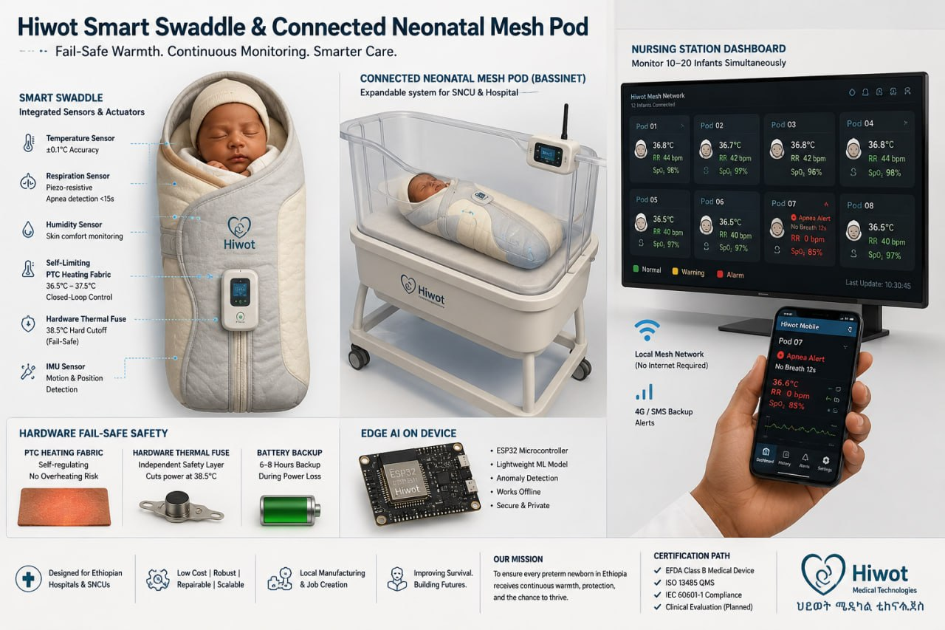
Hiwot Smart Swaddle & Connected Neonatal Mesh Pod — system overview
PROJECT PROPOSAL & PROTOTYPE STATUS REPORT
Submitted by (Group Members):
1. Beemnet Girum
2. Betelhem Tadesse
3. Bethel Yohanes
4. Dawit Mulugeta
5. Etsub Dessalegn
6. Eyuel Wondafrash
7. Musab Mohammedamin
8. Yonas Solomon
Submitted to: INSA Summer Bootcamp Program Instructors / Evaluation Panel
Original Proposal: August 16, 2026 • Revised with Prototype Status Report: August 29, 2026
Addis Ababa, Ethiopia

Table of Contents
1. Executive Summary
2. The Problem, In Numbers & Clinical Evidence
3. Market Opportunity and Defensible Sizing (SAM/SOM)
4. Existing Solutions and Competitive Landscape
5. Proposed Solution: The Hiwot Ecosystem
6. System Architecture
7. Complete Bill of Materials and Equipment
8. The AI & Edge Software Component
9. Safety and Multi-Tier Fail-Safe Design
10. Regulatory Pathway (Ethiopian Food and Drug Authority — EFDA)
11. 2-Month Prototype Development Plan (Original Sprint Design)
12. 12-Month Master Project Roadmap
13. Multidisciplinary Team and Organizational Structure
14. Budget and Funding Request
15. Business Model and Path to Revenue
16. Bench & Non-Clinical Validation Plan
17. Risks and Mitigations Matrix
18. Social Impact Case: Saving Preterm Lives in Ethiopia
19. The Ask and Expected Milestones
20. Sources, Scientific Evidence & References
21. Prototype Progress & Status Report (as of August 29, 2026)

1. Executive Summary
Ethiopia's neonatal mortality rate stands at 33 deaths per 1,000 live births, with preterm-related complications accounting for 34% of all under-five deaths nationwide. Kangaroo Mother Care (KMC) — continuous skin-to-skin contact between a mother and her preterm or low-birth-weight infant — is a proven, WHO- and Ethiopian Ministry of Health-endorsed intervention capable of reducing neonatal mortality by up to 25% to 76%. Landmark 20-year longitudinal follow-up data from Fundación Canguro (Charpak et al., 2016) demonstrates that KMC confers lasting neurodevelopmental protection, reduces severe morbidity, and preserves human capital into adulthood. Yet in Ethiopian clinical settings, only 5–10% of eligible newborns actually receive uninterrupted KMC.
As documented in global systematic reviews of KMC implementation barriers in low- and middle-income country hospitals (ScienceDirect / Elsevier, 2021), the barrier is not clinical reluctance; it is the physical impossibility of continuous 24/7 skin-to-skin coverage. Mothers recovering from cesarean sections (which create a 6–48 hour physical separation), mothers experiencing postpartum hemorrhage or obstetric complications, mothers caring for twins/triplets, and exhausted mothers during night shifts leave vulnerable infants unmonitored in cold bassinets where hypothermia and silent apnea quickly turn fatal.
Hiwot Medical Technologies (ህይወት ሜዲካል ቴክኖሎጂስ), an INSA Summer Camp 2026 innovation project, introduces a sensor-embedded, hardware-fail-safe infant thermal swaddle expandable into a connected IoT bassinet monitoring system. Engineered specifically for Ethiopian district hospitals and secondary newborn care units (SNCUs), Hiwot delivers:
- Closed-Loop Fail-Safe Warmth: Regulated 36.5°C–37.5°C thermal stability using self-limiting PTC heating fabric backed by an independent hardware thermal fuse (38.5°C hard cutoff).
- Non-Invasive Respiration & Vital Monitoring: Continuous piezo-resistive respiratory motion sensing that detects apnea episodes within 15 seconds.
- On-Device Embedded Safety Logic: Thermal control, breathing-anomaly detection, and local display all run on a single dedicated ATmega328P safety microcontroller with zero dependency on network connectivity for core life-safety functions.
- Cloud-Connected Nursing Station & Mobile Companion Dashboard: An ESP8266 (ESP-01) WiFi companion module streams real-time vitals to a ThingSpeak-backed web dashboard, allowing a single night-shift nurse to oversee multiple high-risk preterm infants from bedside or central ward screens.
This proposal requests ETB 2,750,000 (~USD 19,643 at 1 USD = 140 ETB) to fund an intensive 2-month prototype acceleration sprint followed by comprehensive bench testing, mannequin validation, Proteus simulation testbenches, and regulatory dossier preparation for Ethiopian Food and Drug Authority (EFDA) classification. Since the original submission, the team has moved from paper design into active hardware build — Section 21 of this document presents a full status report on prototype progress, engineering pivots, and photographic evidence of work completed to date.

2. The Problem, In Numbers & Clinical Evidence
Preterm birth complications remain the single largest cause of child mortality in Ethiopia. The crisis is characterized by stark epidemiological, physiological, and clinical literature metrics:
- Neonatal Mortality Rate: 33 per 1,000 live births (Ethiopian Demographic and Health Survey / Mini-EDHS).
- Preterm-Related Deaths: 34% of all under-five deaths in Ethiopia are directly attributed to prematurity and low birth weight.
- Preterm Birth Prevalence: ~10.8% of all live births nationwide (~420,000 preterm infants born every year in Ethiopia).
- Low Birth Weight Prevalence: ~17.3% of births (an overlapping cohort of over 670,000 vulnerable infants).
- Documented KMC Coverage Gap: Only 5% to 10% of eligible Ethiopian neonates receive continuous, effective KMC (Discover Public Health, 2025).
- The 20-Year KMC Evidence Base: Landmark 20-year randomized cohort follow-up by Fundación Canguro (Charpak et al., 2016) proved that continuous KMC provides lifelong protective effects against neurodevelopmental deficits, reduces cerebral palsy risk, improves brain volume, and decreases severe morbidity by over 50% compared to traditional bassinet care.
- Multi-Country Adherence & Barrier Analysis: A comprehensive systematic review published in ScienceDirect (Gaceta Sanitaria / Elsevier, 2021) establishes that maternal physical exhaustion, cesarean-section post-operative pain, nighttime unmonitored periods, and acute staffing shortages represent the four systemic bottlenecks preventing continuous skin-to-skin thermal regulation in LMIC health facilities.
- Maternal Mortality & C-Section Burden: Maternal mortality ratio is 401 per 100,000 live births; post-operative maternal recovery creates an unavoidable 6 to 48-hour window where skin-to-skin KMC is physically unachievable.
- Severe Night-Shift Staffing Shortages: In typical Ethiopian public hospital special newborn care units, a single nurse is tasked with monitoring 12 to 25 neonates overnight. Silent cessation of breathing (apnea of prematurity) frequently goes unnoticed until irreversible brain hypoxia or bradycardia occurs.

3. Market Opportunity and Defensible Sizing (SAM/SOM)
Ethiopia has a population of approximately 123 million with a crude birth rate of ~32 per 1,000 people, generating roughly 3.9 million live births annually.

Total Addressable Market (TAM)
- TAM = 3,900,000 annual births × 10.8% preterm rate = ~420,000 preterm infants/year in Ethiopia.
- Across the wider East African Community (EAC) and Horn of Africa, TAM exceeds 1.8 million preterm births annually.

Serviceable Addressable Market (SAM — Desk-Research Sizing)
- Rather than relying on speculative facility counts, our SAM is derived from published 2024 WHO Ethiopia Health Facility Assessments and UNICEF SNCU mapping reports.
- Ethiopia operates approximately 180 public and private tertiary/general hospitals equipped with designated Neonatal Intensive Care Units (NICUs) or Special Newborn Care Units (SNCUs).
- Eligible facility-based preterm deliveries in these ~180 equipped hospitals represent an estimated 75,600 preterm infants annually (18% of total preterm births).

Serviceable Obtainable Market (SOM — Phase 1–2 Initial Commercial Footprint)
- Target: 3 to 5 premier teaching and referral hospitals in Addis Ababa (e.g., Tikur Anbessa Specialized Hospital, Zewditu Memorial Hospital, St. Paul's Hospital Millennium Medical College).
- Initial SOM footprint: 1,500 to 3,000 infants covered annually across 80–120 deployed Hiwot units.

4. Existing Solutions and Competitive Landscape
Current options for neonatal thermal and vital management in low-resource settings fall into two flawed extremes:

1. Traditional Hospital Incubators (e.g., GE Giraffe, Dräger Isolette)
- Cost: ETB 2,800,000 to ETB 4,200,000+ ($20,000 – $30,000 USD) per unit.
- Limitations: Prohibitively expensive, requires uninterrupted grid electricity (rare in rural Ethiopian facilities), demands complex biomedical calibration, and isolates the infant in a bulky plastic enclosure preventing parental bonding.

2. Non-Electric Phase-Change Warmers (e.g., Embrace Infant Warmer)
- Cost: ~ETB 28,000 ($200 USD).
- Advantages: Highly affordable, non-electric wax pouch maintains heat for 4–6 hours.
- Critical Deficiencies: Zero active physiological sensing; zero respiration or apnea detection; zero alarms; zero connectivity. If a baby stops breathing or experiences secondary hypothermia inside an Embrace pouch, caregivers have no way of knowing without manual visual checks.

3. The Hiwot Advantage (The 'Goldilocks' Medical Device)
- Unit Price at Scale: ETB 35,000 – ETB 42,000 ($250 – $300 USD) — a 98% cost reduction compared to traditional incubators.
- Comprehensive Safety & Intelligence: Combines active, closed-loop, fail-safe warming with continuous piezo-respiratory monitoring, on-device anomaly detection, battery backup, an independent offline alarm box, and cloud-connected multi-bed nursing dashboard.

5. Proposed Solution: The Hiwot Ecosystem
Hiwot is architected as an incremental, high-reliability system designed to seamlessly integrate into Ethiopian hospital workflows:

Stage 1 — Hiwot Smart Thermal Swaddle
A wearable, medical-grade heated swaddle with embedded clinical thermistors, PTC self-limiting heating fabric, and local audio-visual alerts (buzzer + LED indicators, plus an on-swaddle LCD status readout). Operates fully autonomously for core thermal and breathing safety, without requiring network or smartphone connectivity. This is the core safety product built during the 2-month summer sprint.

Stage 2 — Connected Cloud Bassinet Pod, Nurse Hub & Mobile App
Adds an ESP8266 (ESP-01) WiFi communication module, mobile IoT companion access, and a browser-based nursing dashboard. A single smartphone, tablet, or ward monitor receives real-time vital streams, battery levels, and instant priority alerts pushed over hospital WiFi to a ThingSpeak-backed cloud channel. This is a deliberate architectural simplification from the original local BLE/ESP-NOW mesh design (see Section 6 and Section 21), chosen because it lets the team stand up a working multi-bed dashboard quickly using infrastructure already available in most Ethiopian teaching hospitals, while the standalone Stage 1 swaddle and its offline safety extension box guarantee that life-safety alerts never depend on that WiFi link being present.

Stage 3 — IoT Micro-Climate Intensive Crib (Future Horizon)
Full environmental enclosure integrating active humidity regulation, phototherapy blue-light arrays, and skin-to-skin transition docking for high-dependency tertiary nurseries.

6. System Architecture
This section has two parts. Section 6.1 describes the original target architecture exactly as proposed; it remains the intended design for the production device. Section 6.2 describes what is being built for the first physical prototype only, chosen to ship a working, testable unit within the sprint's time and component-availability limits. It is not a permanent redesign of the product.

6.1 Original Proposed Architecture (Target Product Design)
As originally proposed, Hiwot uses a dual-MCU, hardware-isolated split: an ATmega328P safety core handles closed-loop thermal regulation and breathing-anomaly detection with no wireless dependency, while a separate ESP32-WROOM-32 runs on-device apnea inference and broadcasts encrypted vitals over a local BLE 5.0 / ESP-NOW mesh to the central nursing station, with no dependency on hospital WiFi or the internet. A small OLED provides the on-swaddle status readout.

6.2 First-Prototype Update — Scoped to the Current Sprint Build Only
Everything in 6.2 applies only to the first physical prototype built during this INSA Summer Camp sprint. It reflects component availability and the time limits of the build, not a change to Hiwot's long-term architecture in 6.1.

1. Unified Safety & Application Core (ATmega328P)
- A single ATmega328P performs all on-swaddle functions: closed-loop thermal regulation, breathing/apnea detection, and the on-device LCD status display.
- It reads dual NTC thermistors (skin and ambient) and generates the PWM signal to the logic-level MOSFET driving the PTC heating layer.
- It reads the piezo respiration sensor through an LM358 conditioning stage and runs a hysteresis-based threshold-crossing detector with a refractory period in embedded C. This on-device check is the offline safety track: it needs no network and no backend server.
- Thermal control and breathing detection share one chip, so the safety logic is kept simple and deterministic, and it is independent of any wireless radio.

2. Telemetry Bridge & Backend AI — Local Network, Not Cloud
- The WiFi module is now an ESP32 used purely as a telemetry bridge: it reads vitals from the ATmega328P over a serial link, packages them as JSON and sends them over WiFi. It runs no AI code.
- For the first prototype that JSON goes to a backend (a laptop running a Python FastAPI service) over the team's own local WiFi network, reached at localhost, rather than to a public cloud channel such as the ThingSpeak path used in an earlier bench iteration.
- The AI model now lives on that laptop backend (Section 8.2). It is 'fully online' only in the sense that it runs as an always-on process on a computer instead of on the microcontroller; because the computer and network are local to the ward, the safety path does not depend on the public internet.
- If the ESP32, the WiFi or the backend is unavailable, the ATmega328P keeps regulating temperature and checking breathing on its own using the on-device threshold detector.

3. Offline Safety Extension Box
- A small companion enclosure, physically separate from the swaddle electronics, houses a redundant ATmega, three status LEDs, a small LCD and a buzzer.
- It guarantees a bedside nurse is alerted to an apnea or hypothermia event even when WiFi and the backend are down.
- Details are in Section 21.5.

4. Display Change: LCD Replaces OLED
- The bedside display changed from a small OLED to a character LCD driven by the shared ATmega328P, for cost and local sourcing reasons.

7. Complete Bill of Materials and Equipment
The bill of materials below reflects the updated single-MCU-plus-WiFi-bridge architecture. Costs are indicative, in Ethiopian Birr (ETB) at 140 ETB/USD, and will be finalized once the custom PTC blanket and PCB revisions described in Section 21 are complete.

Per-Unit Component Breakdown (Updated Architecture)
- ATmega328P Unified Safety & Application MCU (thermal control, apnea logic, LCD driver): ETB 420 ($3) per unit
- ESP8266 / ESP-01 WiFi Telemetry Bridge Module: ETB 350 ($2.5) per unit
- Clinical-Grade Skin NTC Thermistor (±0.05°C): ETB 1,680 ($12) per unit
- Ambient Temperature Reference Sensor (DS18B20/TMP36): ETB 280 ($2) per unit
- Flexible Piezoelectric Respiration Sensor Pad — procured and integrated: ETB 2,100 ($15) per unit
- Character/Graphic LCD Display Module (replaces OLED): ETB 700 ($5) per unit
- Custom In-House PTC Heating Grid (raw PTC elements, sewn into fabric grid — see Section 21.3): materials cost being finalized, in place of a pre-made PTC blanket which is unavailable in the Ethiopian market
- Production-scale alternative, imported PTC blanket from a trusted foreign vendor: indicative landed cost about ETB 1,400–2,100 ($10–$15) per unit, versus about ETB 900–1,300 ($6.50–$9.50) per unit for the in-house fabricated grid. These are planning estimates to be confirmed with quotes.
- Logic-Level MOSFET PWM Driver Sub-Circuit: ETB 560 ($4) per unit
- Redundant Hardware Thermal Fuse (38.5°C trip): ETB 560 ($4) per unit
- 3.7V LiPo Battery + USB-C Charge Management: ETB 1,120 ($8) per unit
- Buck-Boost Regulators (5V/3.3V): ETB 840 ($6) per unit
- Custom PCB, Connectors & Cabling: ETB 2,520 ($18) per unit

Offline Safety Extension Box (New Line Item)
- Secondary ATmega microcontroller: ETB 420 ($3)
- 3× Status Indicator LEDs (Normal / Attention / Alarm): ETB 90 ($0.6)
- Small LCD Display: ETB 700 ($5)
- Local Buzzer: ETB 150 ($1)
- Enclosure & Wiring: ETB 400 ($3)

One-Time Tooling, Test Equipment & Bench Setup
- Calibrated Thermal Imaging Camera & Blackbody Reference: ETB 21,000 ($150)
- Bench Environmental Chamber & Thermal Infant Mannequin: ETB 42,000 ($300)
- Precision SMD Soldering & Rework Station: ETB 16,800 ($120)
- Digital Storage Oscilloscope, DMM & Lab Bench Power: ETB 35,000 ($250)
- 3D Printing Filament & Enclosure Prototyping: ETB 14,000 ($100)
- Cloud Broker (ThingSpeak), Firmware IDEs & Software Subscriptions: ETB 25,200 ($180)
Note: the itemized funding request totals in Section 14 reflect the original approved budget structure; per-line costings above are being re-quoted against local suppliers as the custom PTC blanket fabrication and revised PCB (Section 21) are finalized, and will be reconciled in the next budget revision.

8. The AI & Edge Software Component
Like Section 6, this has two parts: 8.1 is the original plan, and 8.2 is what is being built for the first prototype, led by Eyuel Wondafrash as AI Lead. Hiwot's intelligence is scoped to one verifiable, lifesaving capability: real-time detection of apnea of prematurity (breathing pauses longer than about 15 seconds). During night shifts with 1:20 nurse-to-infant ratios, unassisted observation can miss early apneas.

8.1 Original Plan: On-Device Edge AI (Target Design)
As proposed, apnea detection runs as a quantized TensorFlow Lite Micro model on a dedicated ESP32, fully on-device with no external server. This remains the target for the production device.

8.2 First-Prototype Update: Backend AI + On-Device Offline Fallback
This applies to the first prototype only. AI development has moved off the ESP onto a laptop-hosted backend; the ESP32 only carries telemetry. A simple threshold check stays on the ATmega328P as the offline fallback.
- Where the AI lives. The model, weights and inference server run on a laptop as a Python FastAPI service, on the local network. The ESP32 only forwards JSON readings.
- Offline track. Independently of the backend, the ATmega328P runs its own hysteresis-based threshold check on the piezo waveform, so apnea alerts continue if WiFi or the backend fail.
- Dataset. The 1.6 GB PhysioNet Preterm Infant Cardio-Respiratory Signals Database (PICSDB) has been downloaded and structured.
- Environment. Python virtual environment with TensorFlow, wfdb, FastAPI, uvicorn, numpy and pandas.
- Model. A lightweight 1D-CNN (Conv1D 16, MaxPooling, Conv1D 32, GlobalAveragePooling, Dense 16, sigmoid output) in train_model.py, on 150-sample sliding windows, outputting an anomaly score from 0.0 to 1.0. Labels are currently placeholders; real labels and the training loop are the next milestone.
- Alert rule. An alert is raised on the dashboard if the score stays above 0.85 for more than 15 consecutive seconds.
- Status. About 45% complete per the AI report dated August 29, 2026. Remaining: full training and export (apnea_model.h5), FastAPI integration, the ESP32-to-backend link, and end-to-end WebSocket dashboard testing.

Website & Dashboard
- The nursing dashboard front end is complete. The FastAPI backend is under active development and runs on localhost for the first prototype, consistent with the local-WiFi design in Section 6.2.

9. Safety and Multi-Tier Fail-Safe Design
Because the device delivers thermal energy directly to fragile preterm neonates, patient safety is the central design imperative:
- PTC Self-Limiting Heating Material: Positive Temperature Coefficient (PTC) carbon polymer heating elements inherently increase electrical resistance as temperature rises, making physical overheating above 40°C physics-limited even if continuous DC voltage were applied. As detailed in Section 21.3, the team is now fabricating this heating layer in-house — individual PTC elements laid out in a grid and sewn into the swaddle fabric — because a pre-made PTC blanket product is not available for purchase in Ethiopia.
- Redundant Hardware Thermal Fuse: A non-resettable bimetallic thermal fuse rated at 38.5°C is positioned in direct contact with the heater element in series with the power supply rail. If the microcontroller or MOSFET fails closed, the fuse melts open and cuts power permanently.
- Independent Offline Alarm Path: The new offline safety extension box (Section 21.5) provides a second, physically separate alerting path — LEDs, LCD, and buzzer — so that an apnea or hypothermia alert reaches bedside staff even when hospital WiFi and the cloud dashboard are unavailable, addressing the connectivity risk described in Section 17.
- Galvanic & Fluid Isolation: Electronics are housed in a splash-resistant enclosure that connects to the swaddle via a strain-relieved flexible neck harness (see Section 21.8 photographs). The textile swaddle itself is designed to be detachable and washable.
- Battery Backup & Brownout Protection: Built-in LiPo battery is intended to seamlessly take over during Ethiopian hospital grid fluctuations, preventing false power alarms or sudden loss of thermal regulation; this remains a validation task in the current sprint.

10. Regulatory Pathway (Ethiopian Food and Drug Authority — EFDA)
Hiwot is treated as a regulated medical device from Day 1 in accordance with Ethiopian law:
- Legal Framework: Food and Medicine Administration Proclamation No. 1112/2019, administered by the EFDA.
- Device Classification: Non-IVD active therapeutic/monitoring device. Under EFDA guidelines, patient warming blankets with active monitoring align with Class IIa (moderate-low risk).
- Electronic Submission Portal: Registration dossiers are filed via EFDA's online eRIS portal.
- Summer Camp Project Regulatory Scope: For the scope of this INSA grant and summer acceleration camp, our deliverable is a comprehensive EFDA Classification Desk Review & Pre-Registration Dossier, including ISO 14971 Risk Analysis, IEC 60601-1 electrical safety design files, Proteus circuit simulation logs, and bench validation reports. Full commercial registration will follow Phase 3 multi-site trials.

11. 2-Month Prototype Development Plan (Original Sprint Design)
The original accelerated 8-week summer sprint roadmap, as approved, is retained below for reference. Section 21 reports actual progress against this plan and documents where the team adapted the design during execution.
- Weeks 1–2 — System Architecture & Component Sourcing: finalize schematics and simulation models; source thermistors, heating material, microcontrollers, and PCB stock; freeze connector pinout and power budget.
- Weeks 3–4 — Core Safety Hardware & Closed-Loop Thermal Assembly: mill and assemble the safety-core PCB; flash bang-bang/PID temperature control firmware; validate temperature measurement accuracy; conduct thermal runaway test to verify hardware fuse cutoff.
- Weeks 5–6 — Respiration Subsystem & On-Device Anomaly Detection: integrate the piezoelectric respiration pad with analog signal conditioning; deploy the breathing-anomaly detection logic; bench-test breathing detection on a mechanical mannequin across 0–60 BPM.
- Weeks 7–8 — IoT Nurse Dashboard, Enclosure Integration & Demo Readiness: deploy wireless telemetry to the nurse station dashboard and mobile access; fit electronics into the protective enclosure and integrate with the washable swaddle; run a continuous bench stress test and prepare the pitch deck.
Team ownership by phase: Weeks 1–2 — Musab Mohammedamin & Bethel Yohanes (architecture, schematics, sourcing). Weeks 3–4 — Bethel Yohanes & Betelhem Tadesse (safety core PCB and thermal control loop). Weeks 5–6 — Etsub Dessalegn & Beemnet Girum (respiration sensor pipeline and anomaly detection). Weeks 7–8 — Eyuel Wondafrash & Beemnet Girum (dashboard and mesh/telemetry), with the full team — led by Beemnet Girum, Bethel Yohanes, and Dawit Mulugeta — delivering enclosure integration and the final demo.

12. 12-Month Master Project Roadmap
- Months 1–2: 8-Week Core Safety & IoT Prototype Sprint (Deliverable: Validated Prototype v1.0).
- Months 3–4: 5-Unit Batch Build, Enclosure Hardening & Mannequin Bench Stress Testing.
- Months 5–6: Multi-Bed Telemetry Optimization, Cloud Dashboard Hardening, and Nurse Station Mobile UX Polish.
- Months 7–8: EFDA Pre-Submission Consultation, Institutional Partner Engagement (Referral Hospitals in Addis Ababa).
- Months 9–10: Supervised Bench & Simulated Ward Testing with Clinical Staff Feedback.
- Months 11–12: Comprehensive Bench Performance Report, Regulatory Dossier Finalization, and Phase 3 Funding Round.

13. Multidisciplinary Team and Organizational Structure
Hiwot is built by 8 engineering and biomedical students under the INSA Summer Camp 2026 program. This has been a collaborative build: the circuit, firmware, dashboard and 3D enclosure have each been touched by more than one team member. The roles below describe each person's primary areas of contribution so far, not sole or majority ownership of any component.
- Beemnet Girum — Project Lead & 3D Design Engineer. Led the project (coordination and sprint planning) and worked on the 3D enclosure components.
- Bethel Yohanes — Circuit Simulation, 3D Design & Dashboard. Worked on the Proteus circuit simulation, the 3D enclosure design, and the nursing station dashboard.
- Betelhem Tadesse — Research & Cross-System Code. Carried much of the proposal's clinical and technical research and writing, and contributed code used across every subsystem of the project.
- Etsub Dessalegn — Circuit Design & Verification. Ongoing work on the Proteus circuit file, consistently fixing and refining components as the design evolves.
- Musab Mohammedamin — PCB Design Engineer. PCB schematic capture, layout and routing in EasyEDA, ongoing.
- Eyuel Wondafrash — AI Lead & Website Developer. Currently developing the backend AI apnea-detection model and the website.
- Yonas Solomon — Dashboard Developer. Ongoing work on the nursing station dashboard across several iterative versions.
- Dawit Mulugeta — 3D Design & Website/Dashboard Preparation. Contributed to the 3D enclosure design and to website and dashboard preparation.
As the prototype moves into PTC heating-grid characterization, PCB revision and AI backend integration, these roles will keep evolving and overlapping in the same way.

14. Budget and Funding Request
Total Funding Request: ETB 2,750,000 (~USD 19,643), at 1 USD = 140 ETB (mid-2026 realistic planning rate for imported electronics):
The PTC line carries the in-house fabrication cost for the first-prototype phase; the higher imported-blanket cost applies at production scale (Section 7).
- Hardware & Prototype Components (5 Units): ETB 74,200 ($530)
- Tooling, Test Equipment & Bench Setup: ETB 154,000 ($1,100)
- Student Research Stipends (8 Team Members × 12 Months): ETB 1,344,000 ($9,600)
- Remote Clinical Literature Review & Expert Consultation: ETB 84,000 ($600)
- Import Duty & Expedited Customs Shipping Buffer (25% on electronics): ETB 189,000 ($1,350)
- Mannequin Bench Validation & Lab Consumables: ETB 140,000 ($1,000)
- EFDA Classification Desk Review & Regulatory Dossier Prep: ETB 168,000 ($1,200)
- Cloud Telemetry Server & Dev Subscriptions (12 Months): ETB 25,200 ($180)
- Local Addis Ababa Lab Logistics & Component Travel: ETB 84,000 ($600)
- Project Contingency Buffer (15% for student procurement variance): ETB 487,600 ($3,483)

15. Business Model and Path to Revenue
The customer is the healthcare institution and maternal-child health funding programs, NOT individual impoverished families:

Institutional B2B / B2G Buyer Segments
- Public Hospital NICUs / Maternity Wards: Fleet purchases of 10–25 units per facility.
- Regional Health Bureaus & Ethiopian Ministry of Health: National KMC scale-up initiatives.
- Global Health NGOs & Development Agencies: UNICEF, WHO, Bill & Melinda Gates Foundation, USAID maternal-child health grants.

Unit Economics at Production Scale
- Manufactured Landed Cost: ETB 18,000 – ETB 22,000 ($130 – $155 USD).
- Institutional Sale Price: ETB 35,000 – ETB 42,000 ($250 – $300 USD) per unit (45–50% gross margin).
- Device Reusability: With 40–60 infants supported over a 3-year service life, cost per infant covered is under ETB 700 (~$5 USD) — compared to over ETB 25,000 per infant-day in a traditional commercial incubator.

16. Bench & Non-Clinical Validation Plan
To respect university context and avoid prolonged IRB/ethics approval bottlenecks, Phase 1–2 focuses strictly on non-human bench validation:
- Thermal Accuracy & Step-Response Testing: validate skin temperature sensor accuracy within ±0.05°C across 32.0°C–42.0°C against a certified blackbody reference; verify thermal response time (<12 minutes to stable 36.8°C from 20°C ambient).
- Thermal Runaway & Hard Interlock Stress Testing: deliberately short-circuit the MOSFET gate and lock the safety MCU firmware; confirm the bimetallic thermal fuse reliably cuts all power at 38.5°C within 180 seconds.
- Respiration & Apnea Detection Benchmarking: test the piezoelectric pad on a mechanical neonate simulator with variable BPM (0–60 BPM); validate detection accuracy using PhysioNet apnea waveform replay, targeting >94% sensitivity and <4% false-alarm rate.

17. Risks and Mitigations Matrix
- Risk 1: Preterm respiration motion is extremely subtle and susceptible to motion artifacts. Mitigation: high-gain differential charge amplifier, active bandpass filtering (0.2–1.5 Hz), and a hysteresis-based threshold detector for the offline on-device track, and a 1D-CNN backend anomaly model for the connected track, both tuned against PhysioNet reference waveforms.
- Risk 2: Component import delays and customs tariffs at the Ethiopian border. Mitigation: 25% import duty buffer (ETB 189,000) built into budget; priority sourcing through pre-cleared academic university research channels.
- Risk 3: Hospital power grid instability and voltage spikes. Mitigation: LiPo battery backup with surge protection on the charging input.
- Risk 4 (new): No pre-made PTC heating blanket product is available for purchase in Ethiopia. Mitigation: the team is fabricating the heating layer in-house — sourcing raw PTC self-limiting elements, laying them out in a grid pattern, and sewing them into the swaddle fabric (Section 21.3). This adds bench characterization work but keeps the fail-safe physics of PTC self-limiting heat unchanged.
- Risk 5 (updated): Unstable or absent hospital WiFi could interrupt the cloud dashboard link. Mitigation: the newly added offline safety extension box provides a fully local LED/LCD/buzzer alarm path so a bedside nurse is alerted to an apnea or hypothermia event even with zero network connectivity; the swaddle's core thermal and breathing safety logic never depends on the ESP8266 link in the first place.
- Risk 6 (new): Current hand-built PCB revision does not yet carry every planned component. Mitigation: firmware and core safety functions are being validated on the current board now, with a corrected PCB revision planned for the coming weeks (Section 21.7).

18. Social Impact Case: Saving Preterm Lives in Ethiopia
By extending thermal and vital monitoring during the critical 12–16 hours per day when a mother cannot physically perform Kangaroo Mother Care, Hiwot directly addresses the #1 cause of neonatal mortality in Ethiopia.
The long-term socio-economic return on investment is backed by definitive clinical evidence: the landmark 20-year cohort study by Fundación Canguro (Charpak et al., 2016) demonstrated that preterm infants receiving protected continuous thermal care and KMC grew into young adults with significantly higher IQs, greater brain gray matter volume, lower rates of school absenteeism, and reduced aggressive behavior compared to incubator/unmonitored controls.
Furthermore, by solving the hospital-level adherence barriers identified in the ScienceDirect multi-center systematic review (Elsevier, 2021) — including night-time unmonitored drop-off and post-cesarean maternal exhaustion — Hiwot converts vulnerable “dead zones” into safe healing intervals.
If deployed across Ethiopia's ~180 equipped hospitals, Hiwot has the potential to safeguard over 75,000 preterm infants annually, drastically reducing hypothermia-induced mortality, preventing hypoxic brain damage from unobserved apneas, and easing the overwhelming burden on Ethiopian night-shift healthcare heroes.

19. The Ask and Expected Milestones
We are requesting ETB 2,750,000 (~$19,643 USD) for a 12-month program anchored by an initial 2-month prototype acceleration sprint under INSA Summer Camp 2026.
What This Investment Delivers:
- 5 fully bench-validated, safety-tested Hiwot prototype units, built on the updated single-MCU-plus-WiFi-bridge architecture.
- A complete cloud-connected nursing station dashboard and mobile telemetry access, including the newly added bed management and filtering workflows described in Section 21.6.
- A validated on-device breathing-anomaly detection routine, benchmarked on PhysioNet datasets, with a clear roadmap to a full TinyML pipeline in Phase 2.
- A comprehensive Proteus/EasyEDA circuit simulation suite and hardware testbench.
- A comprehensive EFDA Classification Desk Review & ISO 14971 Risk Dossier.
- A published bench validation report ready for institutional pilot deployment.

20. Sources, Scientific Evidence & References
- Charpak, N., Tessier, R., Ruiz, J. G., et al. (2016). Twenty-year Follow-up of Kangaroo Mother Care Versus Traditional Care. Pediatrics, 139(1): e20162063. Fundación Canguro.
- ScienceDirect / Gaceta Sanitaria (Elsevier, 2021). Kangaroo mother care: A systematic review of barriers and facilitators in clinical and low-resource settings. PII: S0213-9111(21)00052-2.
- UNICEF Ethiopia & Ministry of Health, Kangaroo Mother Care Technical and Implementation Guideline (citing Mini-EDHS 2019).
- Discover Public Health (2025). Effective early Kangaroo Mother Care coverage and associated factors among low-birth-weight neonates in selected hospitals in Oromia region, Ethiopia.
- PMC Systematic Review (2023). The top determinants and magnitude of preterm neonatal mortality in Ethiopia: Systematic review and meta-analysis.
- Ethiopian Food and Drug Authority (EFDA), Proclamation No. 1112/2019 and Medical Device Registration Guidelines (efda.gov.et).
- WHO & UNICEF (2024), Ethiopia Health Facility Assessment & Special Newborn Care Unit (SNCU) Mapping Data.
- PhysioNet Neonatal Apnea Database (open-access preterm infant respiratory waveform archives).
- National Bank of Ethiopia & Commercial Bank of Ethiopia (Foreign Exchange Planning Indicatives, 2026).

21. Prototype Progress & Status Report (as of August 29, 2026)
This section documents what has actually been built since the original proposal was submitted, the engineering trade-offs the team made along the way, and the work that remains. It is intended to give reviewers and pitch audiences a transparent, evidence-backed view of progress — including photographs of the working circuit simulations, PCB layout, electronics enclosure, and nursing dashboard. All eight team members named in Section 13 contributed to the work summarized below.

21.1 Summary of Engineering Changes Since the Original Proposal
- Display: the bedside OLED specified originally has been changed to an LCD module, for cost and local component-sourcing reasons.
- Compute architecture: instead of a dual-MCU split (ATmega328P for safety, ESP32 for Edge AI and mesh networking), the prototype now runs thermal control, breathing-anomaly detection, and the LCD interface all on a single ATmega328P.
- Connectivity: an ESP8266 (ESP-01) module has been added solely to push telemetry outbound over real hospital WiFi to a ThingSpeak cloud dashboard, replacing the original local BLE 5.0 / ESP-NOW mesh design.
- Dashboard: the nursing station web dashboard has gained bed-management controls — an Add Bed button, the ability to delay or delete a bed, and filters for offline, critical (alert), and attention-needed beds, plus the ability to select which track/bay a bed belongs to.
- Heating element: no ready-made PTC blanket product exists in the Ethiopian market, so the team is fabricating the heating layer itself — sourcing individual PTC elements, laying them out in a grid, and sewing them into the swaddle fabric. This sub-assembly is still in progress.
- Respiration sensing: the piezoelectric respiration sensor specified in the original BOM has been procured and integrated into the bench circuit.
- New safety component: an offline extension junction box has been added, giving the system a fully local (network-independent) alarm path.
- PCB: the current hand-populated PCB does not yet carry every component in the final design; a revised layout is planned for the coming weeks.
- Firmware: core control and monitoring code is functionally complete, with only minor refinements remaining before the sprint's Stage 1 firmware is considered final.

21.2 Hardware Architecture Update: Single-MCU Core + ESP8266 Cloud Bridge
Two Proteus 8 Professional schematic-capture sessions below show the breathing-check front end — a piezo sensor feeding an LM358 comparator stage — alongside the ATmega328P core and the ESP32/ESP module used during bench simulation of the heater-control and communication logic. The team used these simulations to validate PWM heater control, the opto-isolated MOSFET driver stage, and the thermal-fuse-equivalent cutoff behavior before committing to the physical build.
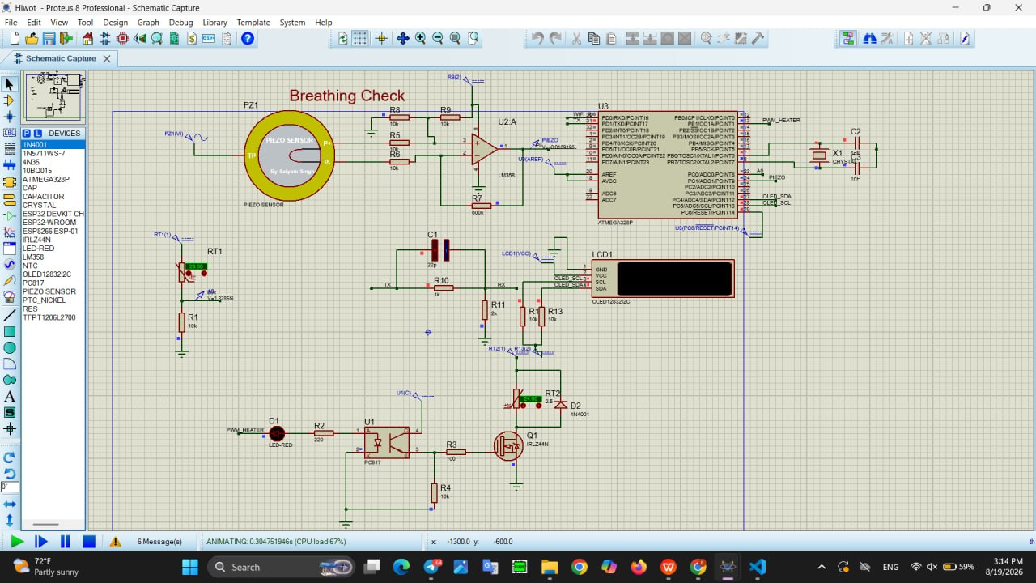
Figure 21.1: Proteus circuit simulation of the breathing-check front end, ATmega328P safety core, heater driver stage, and LCD interface, running live in the simulator.
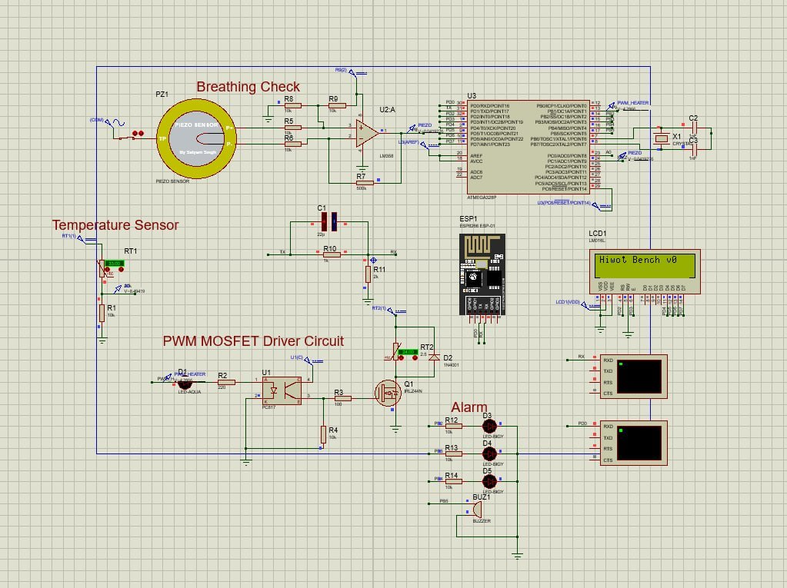
Figure 21.1b: Updated Proteus capture (August 29): breathing-check front end, temperature sensor, PWM MOSFET driver, ESP8266 module, LCD and alarm stage.
The Smart Blanket Electronics Core — the enclosure that houses the swaddle's microcontroller, WiFi bridge, and coin-cell-backed real-time clock — has moved from CAD design to an assembled bench unit. The flexible neck harness carries the sensor and heater conductors from the swaddle fabric into the rigid electronics enclosure, keeping the connection strain-relieved for repeated hospital use.
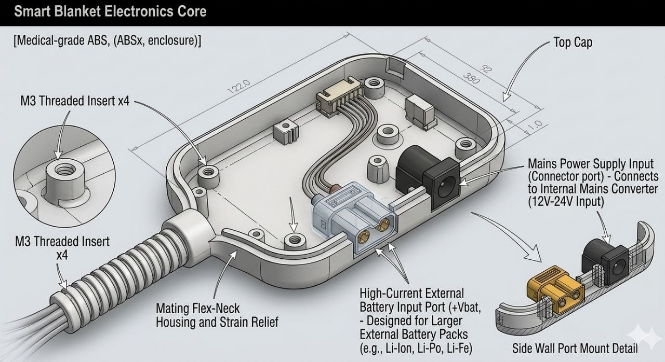
Figure 21.2: Concept illustration (AI-generated, not a photo or CAD capture) of the target electronics core enclosure.
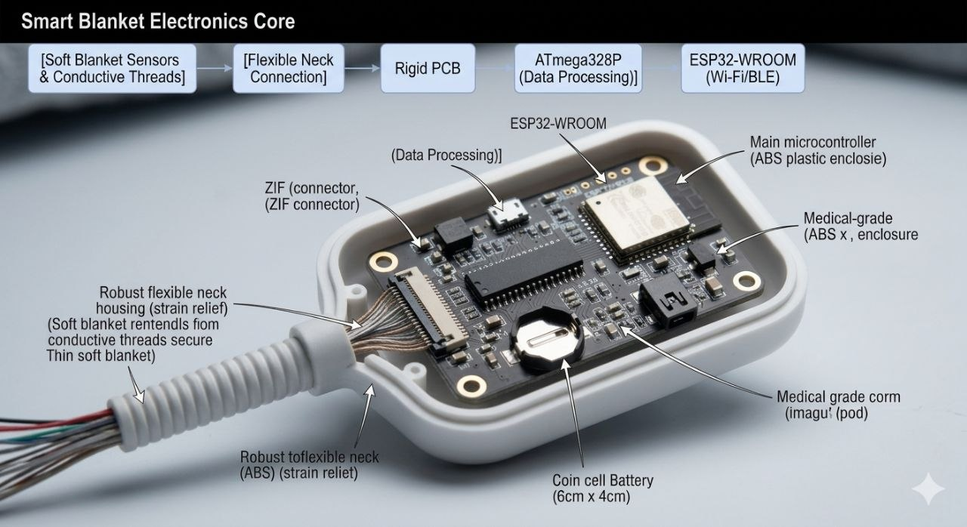
Figure 21.3: Concept illustration (AI-generated, not a photo of the physical build) of the target assembled electronics core.
Note on Figures 21.2–21.3: these are AI-generated concept illustrations of the target enclosure, not photographs or CAD captures. Figures 21.2b and 21.3b are real screen captures from the team's CAD software.
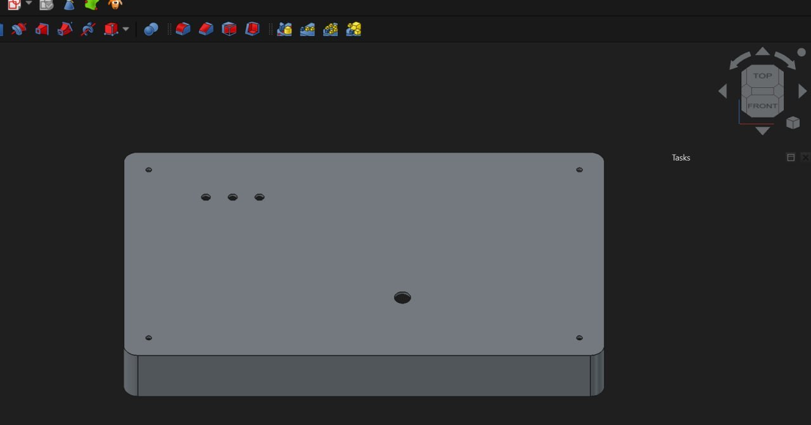
Figure 21.2b: Real CAD capture, top view of the enclosure baseplate with mounting holes and cable pass-through (FreeCAD).
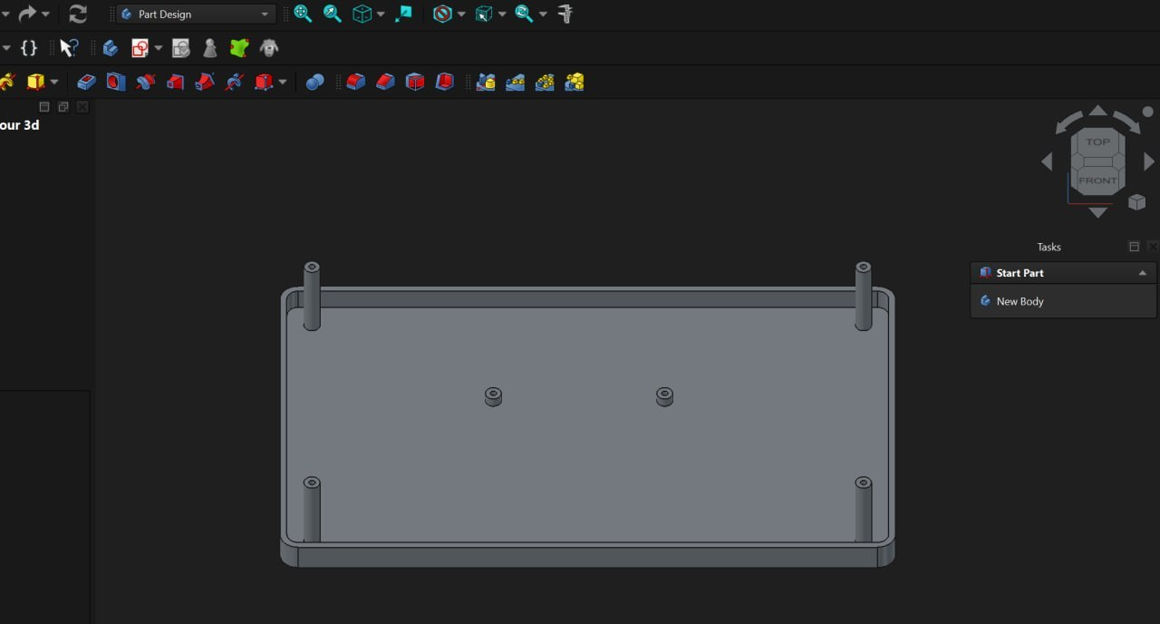
Figure 21.3b: Real CAD capture, isometric view of the enclosure base with corner mounting bosses.

21.3 Custom PTC Heating Blanket: Solving a Local Supply-Chain Gap
During procurement, the team discovered that no supplier in Ethiopia sells a pre-made, medical-suitable PTC (Positive Temperature Coefficient) heating blanket — the core self-limiting heating material specified in the original safety design. Rather than substitute a less safe heating technology, the team decided to fabricate the PTC heating layer from scratch: sourcing individual self-limiting PTC elements and laying them out in a grid pattern, then sewing that grid directly into the swaddle fabric layer. This preserves the key safety property of PTC material — its resistance rises with temperature, physically limiting how hot any single point in the grid can get — while working entirely with locally available raw components.
This sub-assembly has not yet been completed; it is the team's current top hardware priority, and Betelhem Tadesse and Yonas Solomon are leading the grid layout, spacing, and sewing work needed to characterize its heat distribution before it is bench-tested against the blackbody reference described in Section 16.
Sourcing plan, two scenarios: for this first prototype the PTC layer is hand-fabricated in-house, because no ready-made unit is sold in Ethiopia. For production, the plan is to import a pre-made, medical-suitable PTC blanket from a trusted foreign vendor. Both costs are carried in Sections 7 and 14.

21.4 Respiration Sensing: Piezo Sensor Procured and Integrated
The flexible piezoelectric respiration sensor pad specified in the original bill of materials has been procured and is integrated into the current bench circuit, feeding the LM358-based signal-conditioning stage shown in Figure 21.1. This sensor is what the ATmega328P's breathing-anomaly routine (Section 8) monitors to detect apnea events.

21.5 Offline Safety Extension Box
To guarantee that a bedside nurse is alerted to an apnea event even if the ward's WiFi network is down — the exact scenario the original BLE/ESP-NOW mesh was designed to avoid — the team added a small, physically separate offline safety extension box. It contains its own ATmega-based logic, three status LEDs, a small LCD, and a buzzer, and is wired to receive the same alarm signal that the swaddle's core logic generates. When the system is offline, this box is what alerts the nurse to an apnea detection event; when the cloud link is available, the same alert is also pushed to the nursing dashboard described in Section 21.6. This component directly addresses Risk 5 in Section 17.

21.6 Nursing Station Dashboard: New Bed-Management Features
The centralized nursing dashboard has been extended beyond the original real-time vitals view. New functionality now includes:
- An Add Bed control to register a new bassinet/swaddle into the dashboard.
- The ability to delay or delete a bed entry from the active view.
- Status filters to quickly narrow the view to Offline, Alert (critical), or Attention-needed beds, alongside the full “All Bassinets” view.
- Track/Bay selection, so a bed can be tagged to the physical ward bay it is located in, matching how nurses actually navigate a physical SNCU floor.
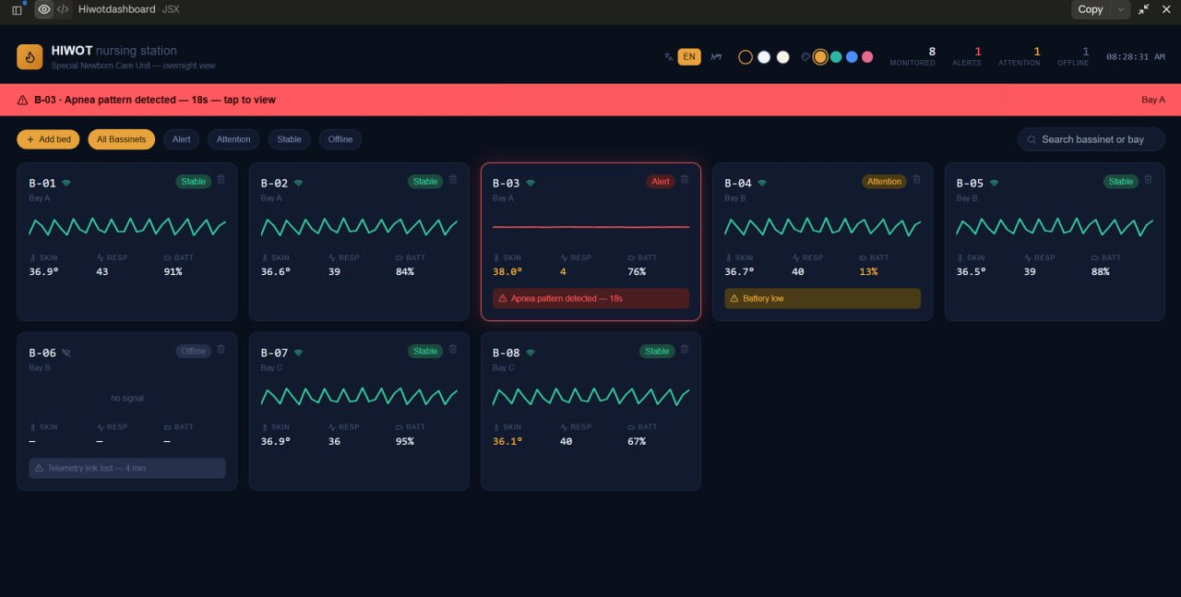
Figure 21.4: Updated nursing station dashboard showing per-bed skin temperature, respiration rate, and battery, an active apnea alert on bed B-03, a low-battery attention flag on B-04, an offline bed (B-06), and the status-filter controls (All / Alert / Attention / Stable / Offline).
Eyuel Wondafrash leads this dashboard work, built as a responsive web front end intended to sit behind the ESP8266-to-ThingSpeak telemetry bridge described in Section 6.

21.7 PCB & Firmware Development Status
The team has moved schematic capture and PCB layout into EasyEDA, covering the power section, temperature sensing, piezo/respiration front end, LCD display, ESP32/WiFi module footprint, MOSFET heater driver, and thermal-management/fuse section on a single board.
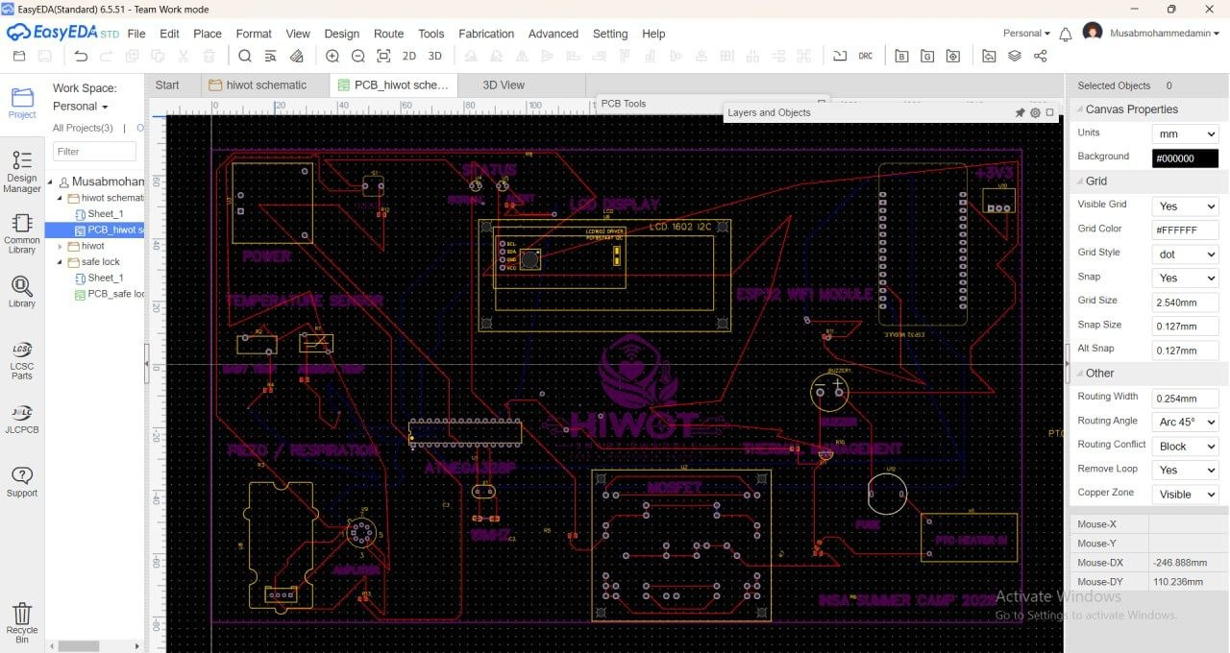
Figure 21.5: EasyEDA schematic-to-PCB routing view for the Hiwot board, showing the power, temperature-sensor, LCD, WiFi-module, piezo/respiration, and MOSFET/thermal-management zones.
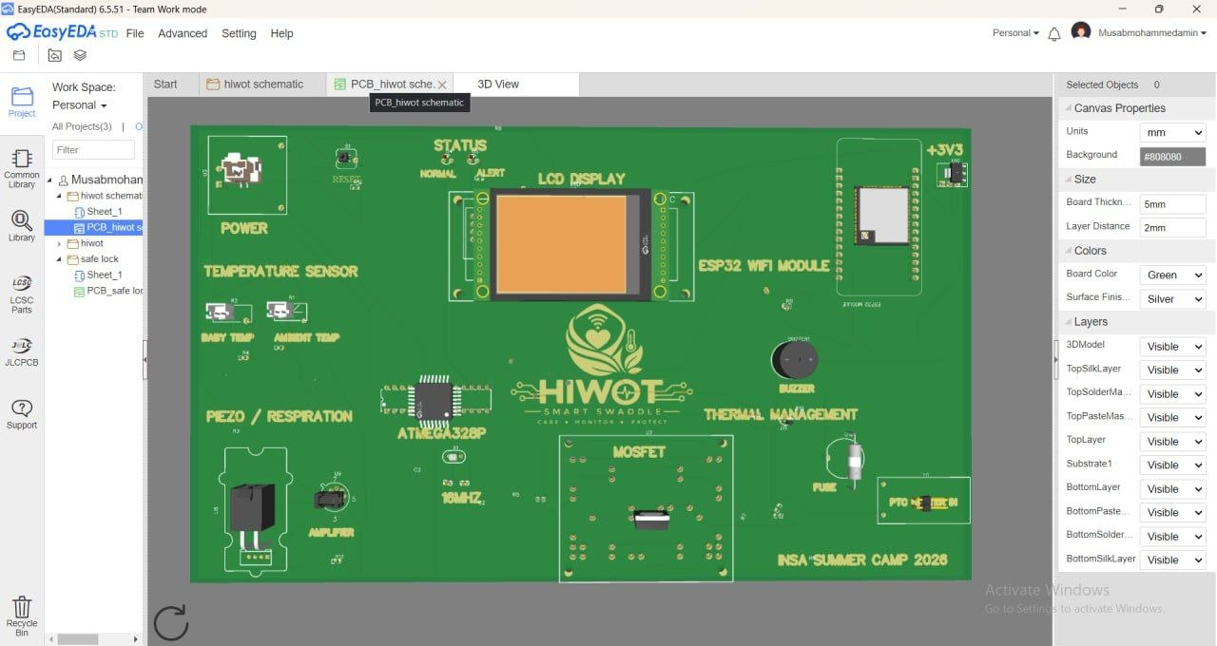
Figure 21.6: 3D PCB render of the current Hiwot board revision, labeled by functional zone — power, temperature sensor, piezo/respiration, ATmega328P, ESP32 WiFi module, MOSFET driver, and thermal management — produced for the INSA Summer Camp 2026 build.
As noted in Section 17 (Risk 6), the current physical PCB does not yet carry every component from the final design — it reflects an intermediate build used to validate layout and routing. Musab Mohammedamin is leading a revised layout in the coming weeks that will bring the board in line with the finalized single-ATmega328P-plus-ESP8266 architecture.
On the firmware side, the team considers the core embedded code — thermal PID/bang-bang control, breathing-anomaly detection, LCD status output, and ESP8266 telemetry push — functionally complete, with only minor refinements remaining before it is finalized for the Stage 1 prototype.

21.8 Visual Progress Gallery
The renders below summarize the full Hiwot concept — smart swaddle, connected mesh pod, and nursing station dashboard — as presented to INSA Summer Camp judges, alongside the physical work completed to date shown in Sections 21.2 and 21.7.
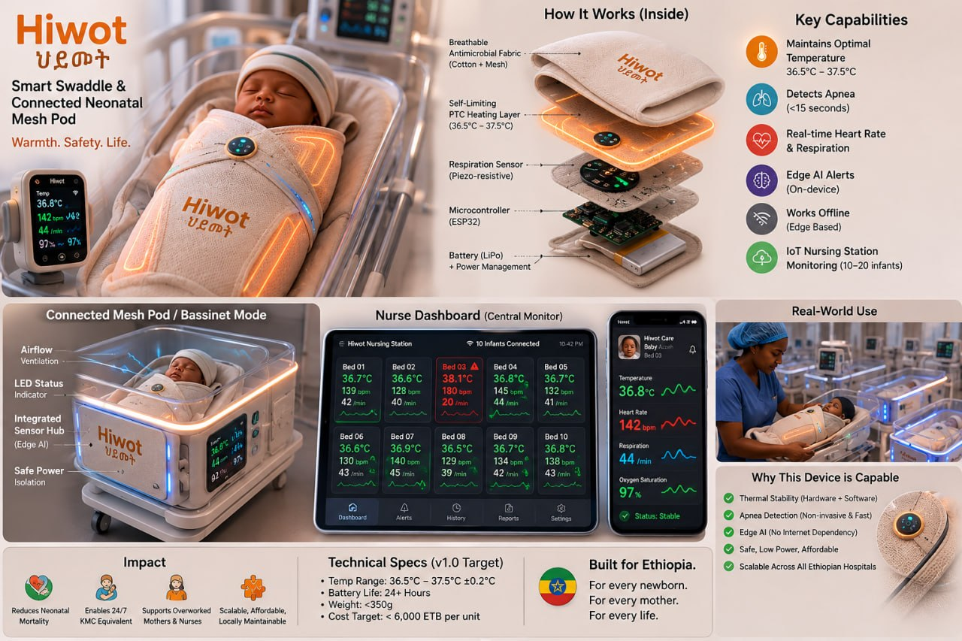
Figure 21.7: Hiwot Smart Swaddle & Connected Neonatal Mesh Pod — sensor stack, key capabilities, and nurse dashboard concept.

21.9 Remaining Work & Next Steps
- Finish sewing and bench-characterize the custom in-house PTC heating grid against the blackbody reference (Section 16).
- Complete the revised PCB layout so the physical board carries every component in the finalized single-MCU-plus-ESP8266 design.
- Close out the remaining minor firmware refinements and run the 24-hour continuous bench burn-in test originally scoped for Week 8 of the sprint.
- Validate the offline safety extension box alongside the cloud dashboard under simulated WiFi-outage conditions.
- Reconcile the updated per-unit BOM costing (Section 7) once the PTC grid and revised PCB costs are finalized.
This status report will be updated as the remaining Stage 1 milestones are completed ahead of the full 2-month sprint demo.

21.10 Latest Captures, Chronology Note and Team Collaboration
Chronology note: the firmware committed to the project repository is the earlier bench iteration (ATmega328P with an ESP8266 sending to ThingSpeak). The current first-prototype plan in Sections 6.2 and 8.2 replaces that cloud path with an ESP32 sending JSON to a local FastAPI backend. The on-device threshold apnea check and thermal loop in the firmware carry over unchanged.
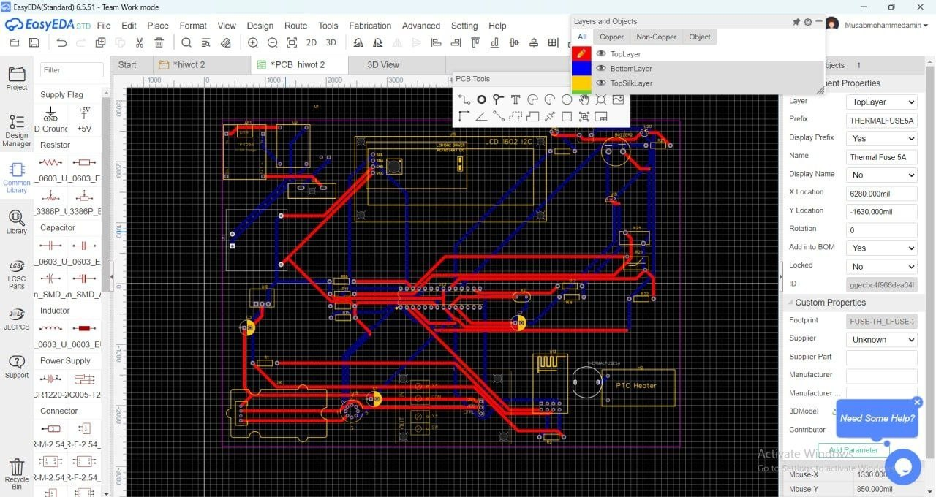
Figure 21.10a: EasyEDA PCB layout and routing (top and bottom copper), Musab Mohammedamin's account, August 29.
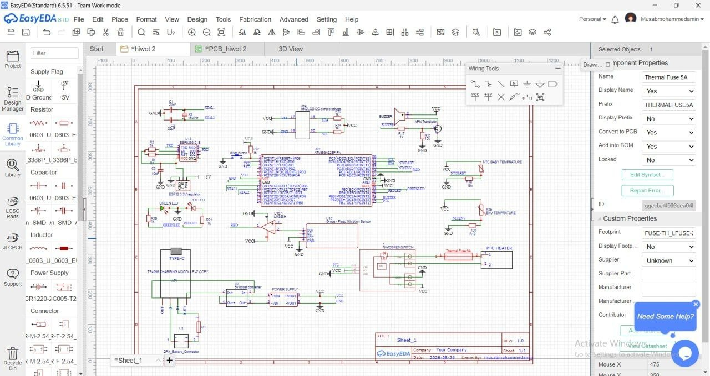
Figure 21.10b: EasyEDA schematic: ATmega328P, TP4056 charger, dual NTC inputs, piezo front end, MOSFET switch with thermal fuse, buzzer and indicator LEDs.
Figure 21.10c: Nursing station dashboard (React/JSX front end), showing alert, attention, stable and offline bed states.
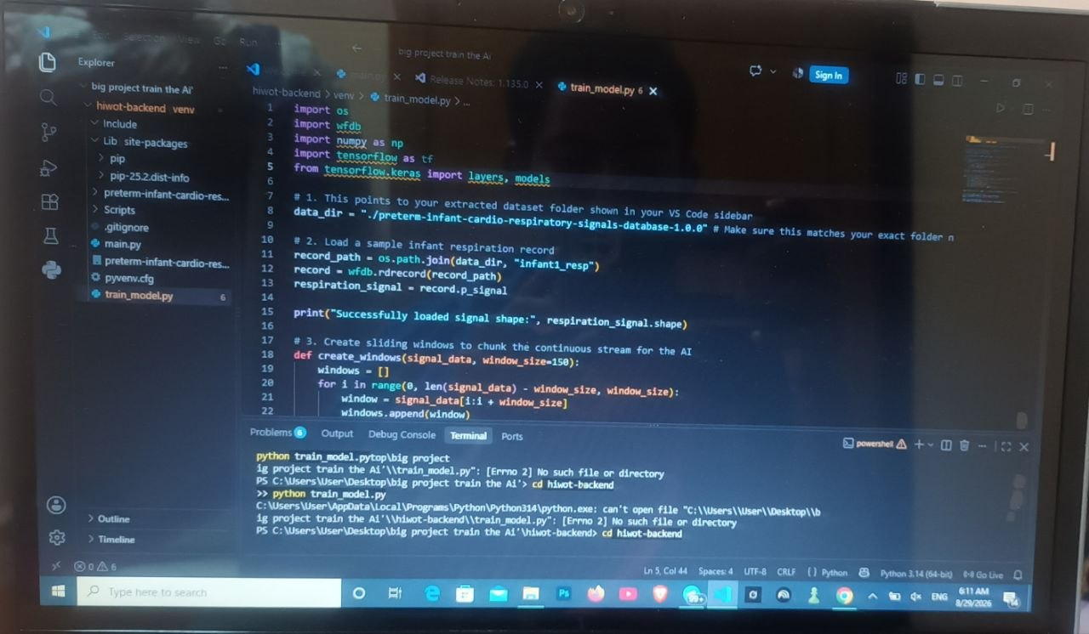
Figure 21.10d: AI development environment (VS Code, Python virtual environment) with train_model.py open, from the AI progress report.

